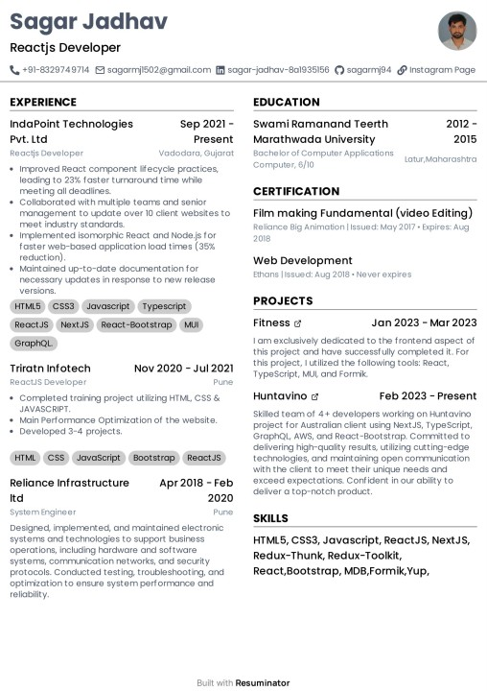
Sagar Jadhav
Reactjs Developer
+91-8329749714 sagarmj1502@gmail.com in sagar-jadhav-8a1935156 sagarmj94 Instagram Page
EXPERIENCE
EDUCATION
IndaPoint Technologies
Pvt. Ltd
Sep 2021 - Present
Swami Ramanand Teerth
Reactjs Developer
Vadodara, Gujarat
• Improved React component lifecycle practices, leading to 23% faster turnaround time while meeting all deadlines.
• Collaborated with multiple teams and senior management to update over 10 client websites to meet industry standards.
• Implemented isomorphic React and Node.js for faster web-based application load times (35% reduction).
Maintained up-to-date documentation for necessary updates in response to new release versions.
HTML5 CSS3 Javascript Typescript ReactJS NextJS React-Bootstrap MUI GraphQL
Triratn Infotech
ReactJS Developer
Nov 2020 - Jul 2021
Pune
• Completed training project utilizing HTML, CSS & JAVASCRIPT.
Main Performance Optimization of the website.
• Developed 3-4 projects.
HTML CSS JavaScript Bootstrap ReactJS
Reliance Infrastructure
Itd
System Engineer
Apr 2018 - Feb
2020
Pune
Designed, implemented, and maintained electronic systems and technologies to support business operations, including hardware and software systems, communication networks, and security protocols. Conducted testing, troubleshooting, and optimization to ensure system performance and reliability.
Marathwada University Bachelor of Computer Applications Computer, 6/10
CERTIFICATION
2012-
2015
Latur, Maharashtra
Film making Fundamental (video Editing) Reliance Big Animation | Issued: May 2017 Expires: Aug
2018
Web Development
Ethans Issued: Aug 2018. Never expires
PROJECTS
Fitness &
Jan 2023 - Mar 2023
I am exclusively dedicated to the frontend aspect of this project and have successfully completed it. For this project, I utilized the following tools: React, TypeScript, MUL and Formik.
Huntavino
Feb 2023 - Present
Skilled team of 4+ developers working on Huntavino project for Australian client using NextJS, TypeScript, GraphQL, AWS, and React-Bootstrap. Committed to delivering high-quality results, utilizing cutting-edge technologies, and maintaining open communication with the client to meet their unique needs and exceed expectations. Confident in our ability to deliver a top-notch product.
SKILLS
HTML5, CSS3, Javascript, ReactJS, NextJS, Redux-Thunk, Redux-Toolkit,
React,Bootstrap, MDB,Formik, Yup,
Built with Resuminator

